SNC1P0 **Particle Theory of Matter Worksheet** Date:__________ Name:________

1. **Use the terms below to complete the Particle Theory statements:**

***motion faster type particles slowly attracted***

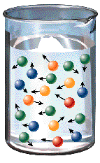1. All matter is made up of tiny ________________.

2. Each type of substance has its own ______________ of particle.

3. The particles of matter are in constant __________________.

4. The particles of matter are ________________ to one another.

5. Temperature affects the motion of the particles. Particles move ____________ at high

temperatures and more _____________ at low temperatures.

1. 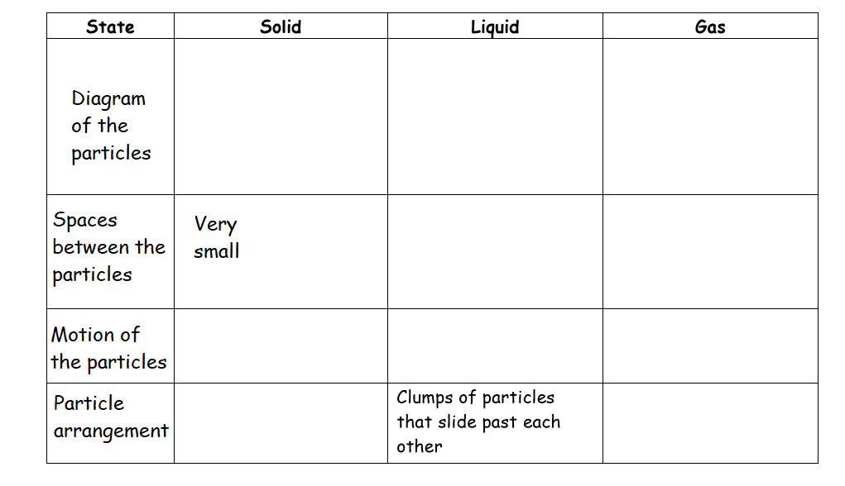**Complete the chart comparing the three states of matter:**
2. **Identify the change of state in each case**:
3. Juice turns into a popsicle in the freezer: ________________________
4. Steam forms when you put a pot of water on a hot stove: _________________
5. A snowman disappears on a warm spring day.:______________________
6. Your kitchen window fogs up when you cook on a cold winter day:___________________
7. Dry ice seems to “boil” away during a concert:__________________

6. Frost appears on the inside of your car window on a very cold day when you breathe on

the window:_______________________

1. **Solids, Liquids and Gases Comparisions!**

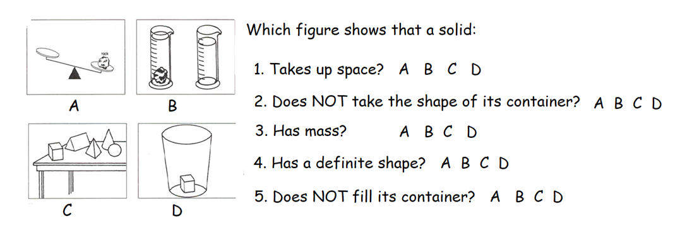 **Solids**

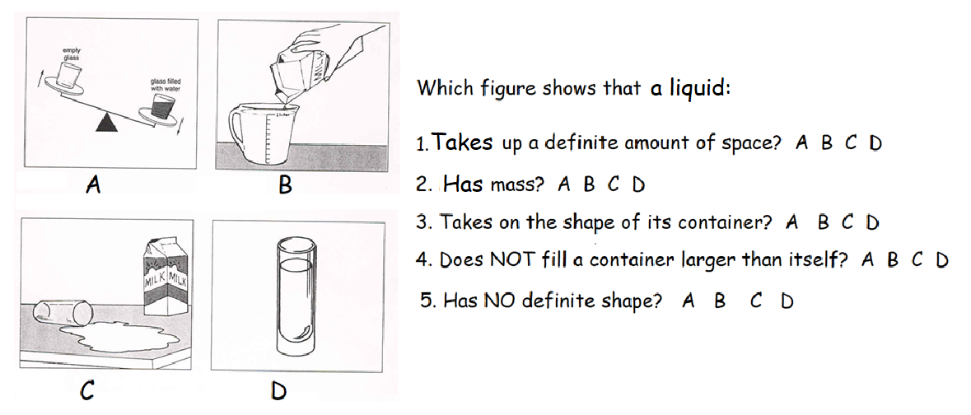**Liquids**

**Gases**

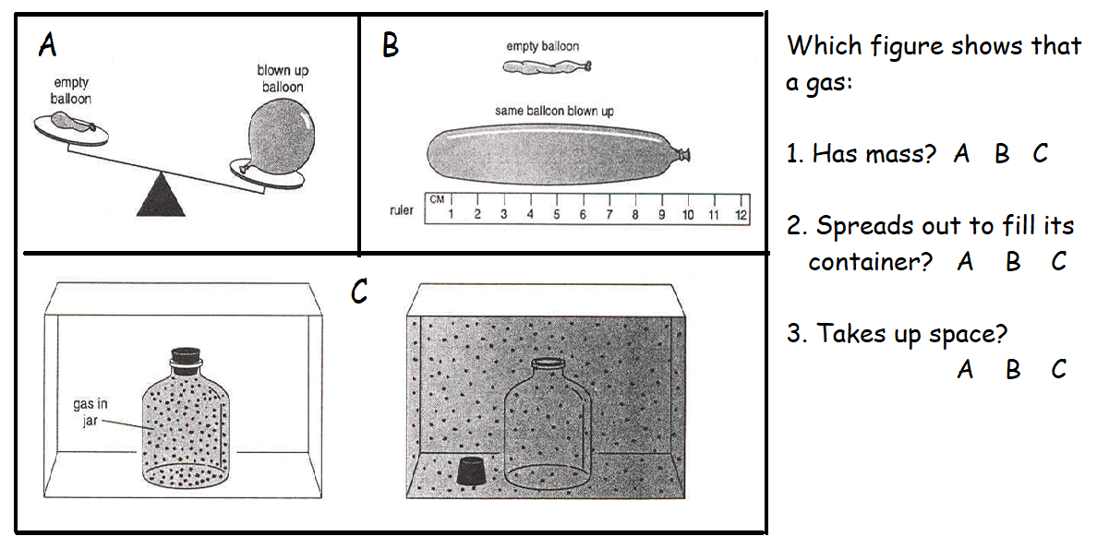

1. **Complete this table about the states of Matter**

|  |  |  |  |  |  |  |  |
| --- | --- | --- | --- | --- | --- | --- | --- |
| State | **Have mass** | **Take up space** | **Take up a definite amount of space** | **Have definite shapes** | **Spread out to take shape of its container** | **Small amounts fill large containers** | **Can be invisible** |
| solids | **YES** |  |  |  |  |  |  |
| liquids |  |  |  |  |  |  |  |
| gases |  |  |  | **NO** |  |  |  |

1. Which properties do all solids, liquids, and gases have?

_______________________________________________________________________

2. Which properties do only gases have?

_______________________________________________________________________

3. Which property do solids and liquids have the gases do not have?

______________________________________________________________________

4. Which property do only solids have?

______________________________________________________________________

5. Which property do liquids and gases have the solids do not have?

______________________________________________________________________